1. **BIT DIVISION**

**EXP NO: 4**

**AIM:** To write an assembly language program to implement 8-bit division using 8085 processor.

**ALGORITHM:**

1) Start the program by loading a register pair with the address of memory location.

2) Move the data to a register.

3) Get the second data and load it into the accumulator.

4) Subtract the two register contents.

5) Increment the value of the carry.

6) Check whether the repeated subtraction is over.

7) Store the value of quotient and the reminder in the memory location.

8) Halt.

**PROGRAM:**

LDA 8501

MOV B, A

LDA 8500

MVI C,00

LOOP:CMP B

JC LOOP1

SUB B

INR C

JMP LOOP

LOOP1:STA 8502

DCR C

MOV A, C

STA 8503

RST 1

**INPUT:**

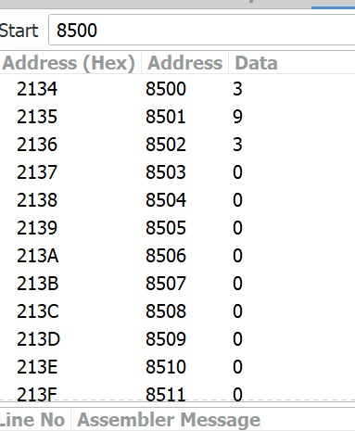

**OUTPUT:**

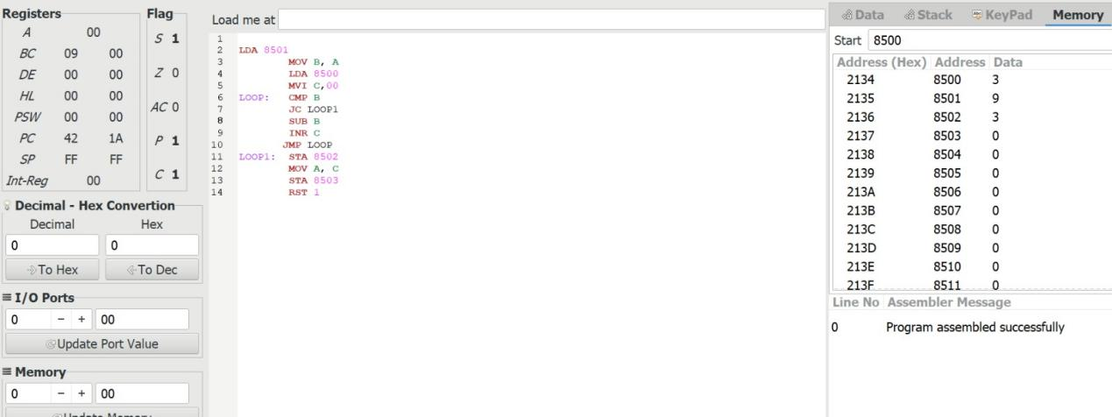

**RESULT:** Thus the program was executed successfully using 8085 processor simulator.